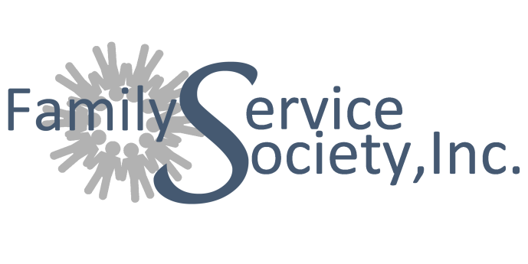

**For Immediate Release**

**More information Contact:**

Iris Brunner

Development Director

Family Service Society, Inc.

765-662-9971 ext 103

[ibrunner@famservices.com](mailto:ibrunner@famservices.com)

***Family Service Society, Inc. Exceeds Goal by Honoring More than 100 Good Men and Reaching $20,000 in Donations***

**Marion, IN (June 19, 2017) –** Family Service Society, Inc. honored more than 100 Good Men and reached $20,000 in donations for its annual ***100 Good Men Campaign*** that ended on Father’s Day. This campaign focuses on the importance of healthy men in the lives of our children, families, and communities. It recognizes the men who consistently **SHOW UP** in the lives of children, **STAND UP** for what is right, and **SPEAK UP** when it matters most.

The campaign offers the opportunity to nominate, make a donation to FSSI and honor the Good Men in our lives by including their names in a recognition list in the Chronicle-Tribune on Father’s Day, and on the Family Service Society, Inc. website. Nominees received a certificate notifying them of their nomination.

“I’ve been lucky in my life to be surrounded by good men in both my personal and professional life,” said Lisa Dominisse, President/CEO of Family Service Society, Inc. “Some individuals have not been so lucky and yearn for strong male role models. This makes it even more important that we shine a light on all the good men and the positive things they are doing to make our lives and communities better. This campaign is our opportunity to showcase our Good Men and the influence they have on making our families strong and in helping our communities thrive,” said Dominisse.

Of those nominated, includes Jake Stroup. Megan Stroup selected him as one of our 100 Good Men because, in her words, “Jake is a leader in his business. He is a leader in our home where he is adored by our children and I. He amazes me with his ability to confidently take calculated risks to improve outcomes for both of our businesses and ultimately our family. I’m proud to say Jake is my husband and to be able to honor him in this way. Being a man of honor in today’s society is a challenge but it’s a choice Jake makes every day.”

The funds donated to this campaign and by supporters will allow Family Service Society, Inc. assist more people through our education and training programs, domestic violence prevention and intervention and counseling programs.

For a complete list of all those nominated, please visit: [www.famservices.com/100gm](http://www.famservices.com/100gm)

#####

**About Family Service Society, Inc.**

Family Service Society, Inc. exists to encourage, empower and educate children, adults and families to change their lives for good. Since 1919, FSSI a 501(c)3 community based agency located at 101 S. Washington St, Marion, IN has helped children, adults and families find help for life’s problems through clinical services, home and school –based programming, Healthy Families and Hands of Hope. FSSI is a regional leader, in over 14 counties, by offering innovative therapeutic services, delivered with integrity, to positively impact the emotional well-being of children and families to create generational change.

101 S. Washington Street, Marion IN, 46952 | Tel: 765-662-9971 | Fax: 765-651-6556   
Email: famservices@famservices.com | Website: www.famservices.com



Partially funded by the   
United Way of Grant County & the   
United Fund of Wabash County

101 S. Washington Street, Marion IN, 46952 | Tel: 765-662-9971 | Fax: 765-651-6556   
Email: famservices@famservices.com | Website: www.famservices.com



Partially funded by the   
United Way of Grant County & the   
United Fund of Wabash County



Partially funded by the   
United Way of Grant County & the   
United Fund of Wabash County